**Configuration of Log4j Programatically**

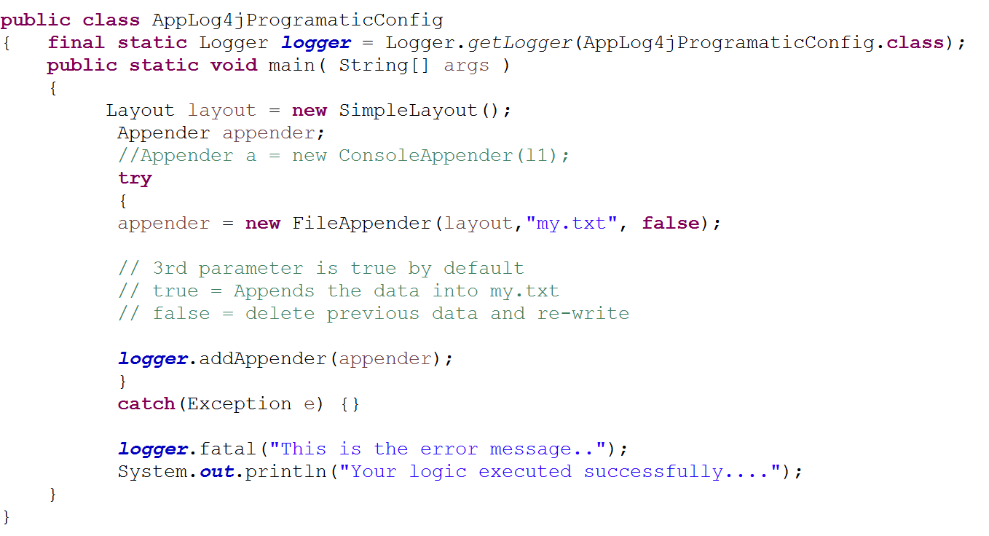

**Explanation**

* First step is to create one Logger class object
* Second step is to create Layout object
* Once Layout is ready, our next step is to create Appender
* In appender i have passed 3 parameters like.. first parameter is object of layout because, appender will write the error messages based on the layout we selected, then 2nd parameter is file name with extension [ in this file only appender will writes the messages ], then 3rd parameter is by default true, means appender will appends the error messages, if we give false then appender will clears the previous data in my.txt file and write newly

We’ve used FileAppender, but you would like to change the appender choice to ConsoleAppender, then again we must open this java file then modifications and recompile…, so to avoid this we can use one .properties file.